|  |
| --- |
| Presents: |
| The Wandering Swordsman |
| **“payday”** |
| Version #01  All work Copyright © 2022 by team awesome! Games.  All rights reserved. |
| **Produced by**  **Scott "RockCat" Davis**  **Tyler “tyyislost” Gribbon**  **Joshua “LoRoo” Stephens** |
|  |

|  |
| --- |
| September 22, 2022 |

**Table of Contents**

Table of Contents

Version History 4

Game Overview 4

Game Play Mechanics 4

Camera 4

Controls 4

Saving and Loading 5

Interface Sketch 5

Menu and Screen Descriptions 5

Game World - CREATIVITY! 5

Levels 5

Game Progression 6

Characters 6

Non-player Characters 6

Enemies 6

Weapons 6

Items 7

Abilities 7

Vehicles 7

Script 7

Scoring 7

Puzzles/Mini-games 7

Bonuses 7

Cheat Codes 7

Sound Index 7

Story Index 7

Art / Multimedia Index 9

Design Notes 9

Future Features 9

# Version History

[This is where you keep track of the detailed changes made to your document throughout the course of development.]

[This is the body of your video game design document. You should add and delete sections as they pertain to your game’s design.]

# Game Overview

*The goal of the game is complete all levels, defeat bosses (found at 10 level increments) as well as complete high-scores within the levels.*

## Game Play Mechanics

*Players can run through the course/map and fight enemies and monsters with their sword. Each level progressively gets harder and enemies become stronger.*

## Camera

*60degree isometric. moves with the character*

## Controls

*Walk forward:* ***W*** *OR* ***Right Arrow Key***

*Walk backward:* ***S*** *OR* ***Left Arrow Key***

*Parry left:* ***Q***

*Parry right:* ***E***

*Slash attack:* ***Space bar***

*Rechargeable slash attack (small cooldown): Hold down* ***space bar***

*Special attack (longer cooldown): Double press* ***space bar***

## Saving and Loading

*Saving and loading will take place in between levels (maps)… as well as loading to prepare the new level/map.*

## Interface Sketch

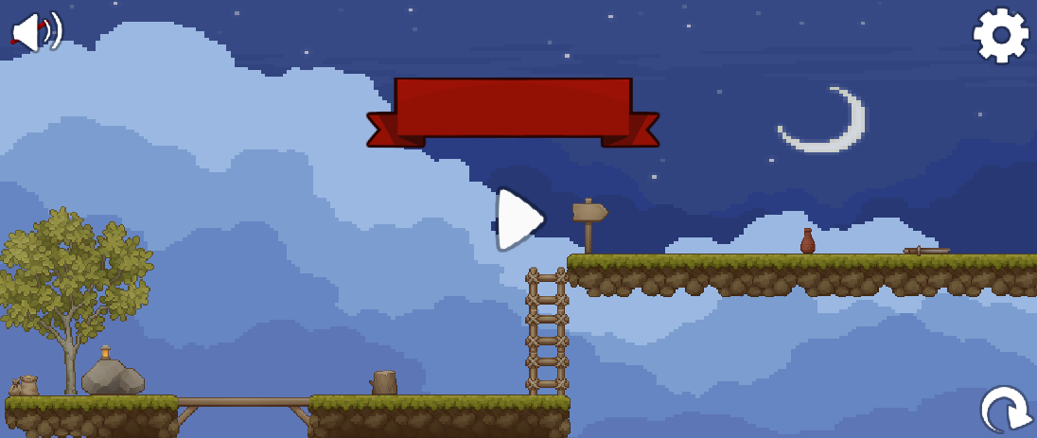

## Menu and Screen Descriptions

*(Include additional screen shots and accompanying descriptions for any menus and additional screen)*

***PAUSE SCREEN:*** *Allows the user to pause during levels, has a settings button, sound on/off slider, and an exit to main menu option.*

## Game World - CREATIVITY!

*1400 Japan, forests, mountains, villages*

## Levels

*village to village will be a level, grassland level, mountain level, dungeon level, crypt level (final boss)*

# Game Progression

## Characters

The wandering swordsman’s outward appearance may portray that he’s a decrepit, frail man with his aged skin and a white beard. Though looks can be deceiving in this case as he’s a legendary swordsman who’s coined the name “the wandering swordman” from the endless tales talked about him (idk if you guys wanna already make him “num 1” or make him progress through the game to achieve that title “num 1/the wandering swordsman”)

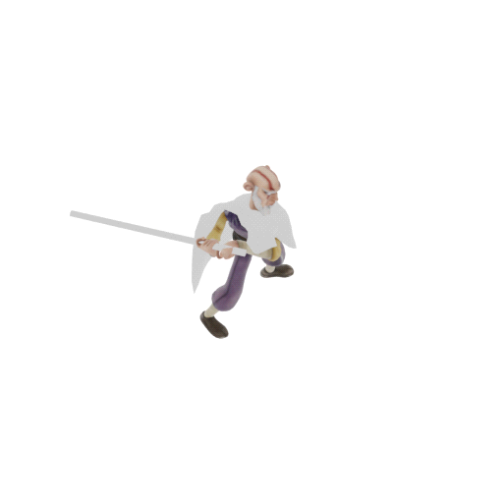

## Non-player Characters

villagers and merchants… give you quests and moneys.

## Enemies

* bandits
* thieves
* gunslingers
* ninjas
* a demon end boss that is near impossible

## Weapons

*The legendary katana named “Zangetsu” that has been passed down for generations*

## Items

*alcohol, potions, food*

## Abilities

*Slashes, charged slashes*

## Vehicles

**N/A**

## Script

## Scoring

High-scores for each level can be achieved. This is based on the players overall time within 1 level.

## Puzzles/Mini-games

**N/A**

## Bonuses

**N/A**

## Cheat Codes

# Sound Index

*(Include an index of all your sound clips)*

# Story Index

**Story 1:** the wandering swordsman has spent his entire life training to honor his family name by becoming the number 1 deadliest swordsman that is comparable to none, even the infamous demon king that was last seen by the wandering swordsman’s great, great, great ancestors. We start the game when the wandering swordsman has already achieved becoming number 1 and devoted his remaining years teaching others. On a bleak and rainy night one of the wandering swordsman’s star pupils (don’t have a name) betrays him by killing all the other students and stealing the wandering swordsman’s number 1 headband/relic (not sure which u wanna do). The wandering swordsman however wakes up while the star pupil is stealing the headband but isn’t quick enough to act and is mortally wounded by his star pupil. The wandering swordsman is revived by an angel who tells him that his star pupil has been corrupted by the demon king to release him from his crypt that his ancestors locked him in a long time ago. The wandering swordsman’s last quest/voyage has begun and it’s up to him to defeat all that stands in his way from saving his pupil, avenging his students, obtaining his number 1 headband/relic and killing/imprisoning the demon king.

**Story 2:** The wandering swordsman has spent his entire life training to honor his family name by becoming the number 1 deadliest swordsman that is comparable to none, even the infamous demon king that was last seen by the wandering swordsman’s great, great, great ancestors. The wandering swordsman never tried to pursue it though as he saw many try and fail costing them their lives. He chose to live a simple life instead, framed the land, have a family, though he never stopped with his training. He passed on all his knowledge to his son/daughter, who in turn taught it to his/her son/daughter. One fateful night during a blood moon (idk just trying to make it more eerie) the wandering swordsman is woken up by a blood-curdling scream. He races outside to find the owner of the blood-curdling scream and becomes paralyzed in horror as he finds his whole family torn to shreds. The only clue to find out who killed his entire family is a bloody trail leading off the farm. Blood boiling and tears running down his face the wandering swordsman sprints to the ancestry grave, retrieves the legendary sword that has been passed down from generation to generation then storms off to find the ones responsible for destroying everything he hold dear. **Note:** the person responsible for this is the number 1 deadliest warrior and the wandering swordsman has to work his way up by killing all of the other deadliest warriors to find him and when he does it can turn out to be the demon king who killed the wandering swordsman’s entire family to get revenge for his ancestors imprisoning/killing him. But the demon king had failed because he didn’t wipe out the entire clan (the wandering swordsman).

# Art / Multimedia Index

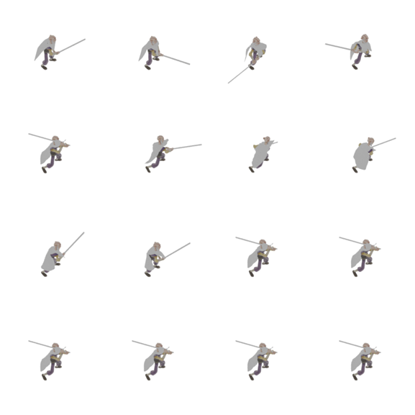

# Design Notes

*(Include additional design notes here)*

# Future Features

*(Include any future features that are planned to be implemented)*

* *Bosses at every 10 levels to add more challenges to the game.*
* *Friends leaderboard for time to complete level.*